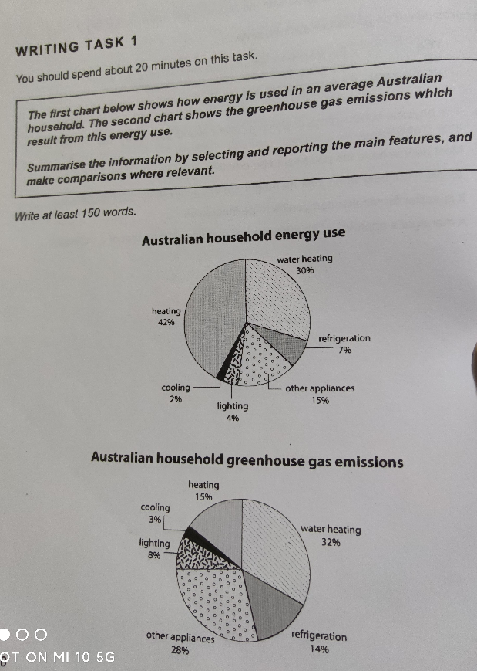

The two pie charts show the energy use in every Australian household and the amount of greenhouse gas emissions from energy consumption.

The vast majority of energy was consumed for heating and water heating in each Australian household. Heating made up 42% of the total energy use and heating water was 30%. The remaining energy was consumed for cooling, lighting, refrigeration, and other appliances, which were 2%, 4%, 7%, and 15% respectively in the total energy use.

The situation of greenhouse gas emissions in every Australian household was not as identical as its energy use. The part of water heating is virtually the same as other appliances, and they made up the largest parts of total emissions, with 32% and 28% respectively. At the same time, the situation of heating and refrigeration is also similar, which made up 15% and 14% of gross emissions. As for the rest of the items, including cooling and lighting, they occupied 3% and 8% of the greenhouse gas emissions.

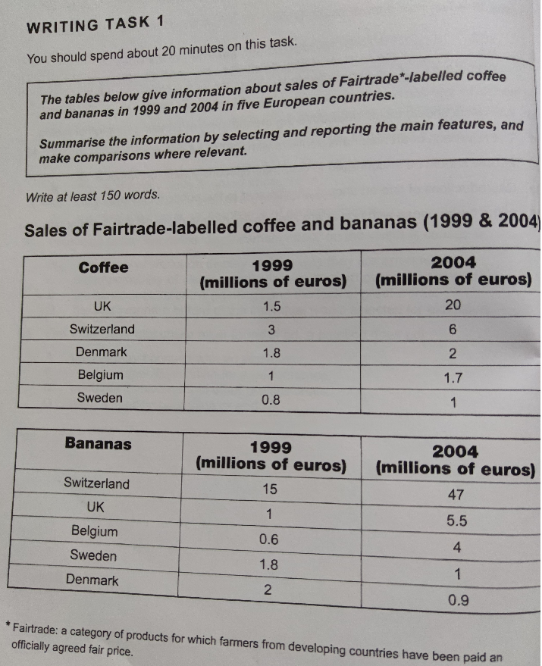

The two charts show the sales breakdown for Fairtrade-labelled coffee and bananas in 1999 and 2004 in five European nations.

First, coffee sales in the UK skyrocketed dramatically between 1999 and 2004 from 1.5-20 million euros. The situation in 1999 and 2004 in Switzerland and Belgium displayed similar increased trend, with sales of coffee increasing largely from 3-6 million euros and from 1-1.7 million euros, while in Denmark and Sweden sales rose slightly from 1.8-2 million euros and from 0.8-1 million euros respectively.

Secondly, sales of bananas in Switzerland, the UK, and Belgium in 1999 and 2004 doubled several times from 15-47, from 1-5.5, and from 0.6-4 million euros respectively. By contrast, the situation in Sweden and Denmark was different, in which sales of bananas in 1999 and 2004 in Sweden decreased largely from 1.8-1 million euros, while in Denmark sales also declined significantly from 2-0.9 million euros.

Comparing the two tables, it is clear that the UK sold the most amount of coffee in 2004, while Switzerland sold the most amount of bananas in 1999 and 2004.

